PROGRAM 1:-
AIM
To solve the 8-Puzzle problem by finding a sequence of moves that transforms the initial puzzle configuration into the goal configuration using a search algorithm.
ALGORITHM
- Start the program.
- Accept the initial state of the 3×3 puzzle from the user.
- Accept the goal state of the puzzle.
- Compare the initial state with the goal state.
- Generate all possible moves by moving the blank space (0) up, down, left, or right.
- Select the valid move and create the next puzzle state.
- Repeat generating new states until the goal state is reached.
- Display each intermediate puzzle state.
- Display the total number of moves (if required).
- Stop the program.
PROGRAM:-
from queue import PriorityQueue
goal = [[1, 2, 3],
[4, 5, 6],
[7, 8, 0]]
class Node:
def __init__(self, state, parent, g):
self.state = state
self.parent = parent
self.g = g
self.h = self.heuristic()
self.f = self.g + self.h
def heuristic(self):
count = 0
for i in range(3):
for j in range(3):
if self.state[i][j] != 0 and self.state[i][j] != goal[i][j]:
count += 1
return count
def __lt__(self, other):
return self.f < other.f
def find_blank(state):
for i in range(3):
for j in range(3):
if state[i][j] == 0:
return i, j
def copy(state):
return [row[:] for row in state]
def get_neighbors(state):
neighbors = []
x, y = find_blank(state)
moves = [(-1,0),(1,0),(0,-1),(0,1)]
for dx, dy in moves:
nx, ny = x + dx, y + dy
if 0 <= nx < 3 and 0 <= ny < 3:
new_state = copy(state)
new_state[x][y], new_state[nx][ny] = new_state[nx][ny], new_state[x][y]
neighbors.append(new_state)
return neighbors
def print_path(node):
path = []
while node:
path.append(node.state)
node = node.parent
path.reverse()
print("Solution Steps:")
for state in path:
for row in state:
print(row)
print()
def solve(start):
pq = PriorityQueue()
start_node = Node(start, None, 0)
pq.put(start_node)
visited = []
while not pq.empty():
current = pq.get()
if current.state == goal:
print_path(current)
return
visited.append(current.state)
for neighbor in get_neighbors(current.state):
if neighbor not in visited:
pq.put(Node(neighbor, current, current.g + 1))
print("No solution found.")
start = [[1, 2, 3],
[4, 0, 6],
[7, 5, 8]]
solve(start)
OUTPUT:-
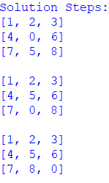
RESULT:- The 8-Puzzle problem was successfully solved by generating valid moves of the blank tile and reaching the specified goal state.
PROGRAM 2:-
AIM
To solve the 8-Queen Problem by placing 8 queens on an 8×8 chessboard such that no two queens attack each other.
ALGORITHM
- Start the program.
- Create an 8×8 chessboard and initialize it with empty positions.
- Place a queen in the first row.
- Check whether the selected position is safe from previously placed queens.
- If the position is safe, place the queen and move to the next row.
- If no safe position is available, backtrack to the previous row and change the queen's position.
- Repeat the process until all 8 queens are placed safely.
- Display the final chessboard configuration.
- Stop the program.
PROGRAM
N = 8
board = [[0 for i in range(N)] for j in range(N)]
def is_safe(row, col):
for i in range(col):
if board[row][i] == 1:
return False
i, j = row, col
while i >= 0 and j >= 0:
if board[i][j] == 1:
return False
i -= 1
j -= 1
i, j = row, col
while i < N and j >= 0:
if board[i][j] == 1:
return False
i += 1
j -= 1
return True
def solve(col):
if col >= N:
return True
for i in range(N):
if is_safe(i, col):
board[i][col] = 1
if solve(col + 1):
return True
board[i][col] = 0
return False
if solve(0):
print("Solution:")
for row in board:
print(row)
else:
print("No solution exists.")
OUTPUT:-
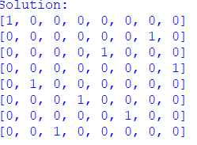
RESULT:-
The 8-Queen Problem was successfully solved using the backtracking technique, and 8 queens were placed on the chessboard such that no two queens attack each other.

PROGRAM 3:-
AIM
To solve the Water Jug Problem using state-space search by transferring water between two jugs to obtain the required amount of water.
ALGORITHM
- Start the program.
- Define the capacities of the two jugs.
- Define the initial state as (0, 0).
- Generate possible operations:
  - Fill the first jug.
  - Fill the second jug.
  - Empty the first jug.
  - Empty the second jug.
  - Pour water from the first jug into the second jug.
  - Pour water from the second jug into the first jug.
- Check each new state and avoid already visited states.
- Continue generating states until the required amount of water is obtained.
- Display the sequence of states leading to the solution.
- Stop the program.
PROGRAM
from collections import deque
def water_jug(jug1, jug2, target):
visited = set()
queue = deque()
queue.append((0, 0, []))
while queue:
x, y, path = queue.popleft()
if (x, y) in visited:
continue
visited.add((x, y))
path = path + [(x, y)]
if x == target or y == target:
print("\nSolution Steps:")
for state in path:
print(state)
return
next_states = [
(jug1, y),
(x, jug2),
(0, y),
(x, 0),
(max(0, x - (jug2 - y)), min(jug2, x + y)),
(min(jug1, x + y), max(0, y - (jug1 - x)))
]
for state in next_states:
if state not in visited:
queue.append((state[0], state[1], path))
print("No solution possible.")
jug1 = int(input("Enter capacity of Jug 1: "))
jug2 = int(input("Enter capacity of Jug 2: "))
target = int(input("Enter target amount: "))
water_jug(jug1, jug2, target)
OUTPUT:-
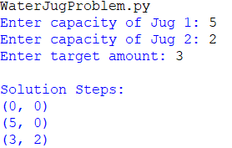
RESULT
The Water Jug Problem was successfully solved by applying the possible water-transfer operations and obtaining the required quantity of water.
PROGRAM 4:-
AIM
To solve a Crypt-Arithmetic Problem by assigning unique digits to the letters in a given arithmetic expression so that the equation is mathematically correct.
ALGORITHM
- Start the program.
- Read the given crypt-arithmetic equation.
- Identify all the unique letters in the equation.
- Assign different digits from 0 to 9 to each letter.
- Ensure that the first letter of a number is not assigned 0.
- Generate possible digit assignments using backtracking.
- Substitute the assigned digits into the equation.
- Check whether the arithmetic equation is valid.
- Display the valid letter-to-digit assignment.
- Stop the program.
PROGRAM
from itertools import permutations

letters = 'SENDMORY'

for p in permutations(range(10), len(letters)):
d = dict(zip(letters, p))

if d['S'] == 0 or d['M'] == 0:
continue

SEND = 1000*d['S'] + 100*d['E'] + 10*d['N'] + d['D']
MORE = 1000*d['M'] + 100*d['O'] + 10*d['R'] + d['E']
MONEY = 10000*d['M'] + 1000*d['O'] + 100*d['N'] + 10*d['E'] + d['Y']

if SEND + MORE == MONEY:
print("Solution:")
print("S =", d['S'])
print("E =", d['E'])
print("N =", d['N'])
print("D =", d['D'])
print("M =", d['M'])
print("O =", d['O'])
print("R =", d['R'])
print("Y =", d['Y'])
print()
print(SEND, "+", MORE, "=", MONEY)
break
OUTPUT
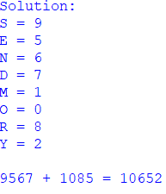
RESULT
The Crypt-Arithmetic Problem was successfully solved by assigning unique digits to the letters and obtaining a valid arithmetic equation.
PROGRAM 5:-
AIM
To solve the Missionaries and Cannibals Problem using a state-space search technique by safely transporting all missionaries and cannibals from one side of the river to the other without violating the given constraints.
ALGORITHM
- Start the program.
- Represent the state as (M, C, B), where M is the number of missionaries, C is the number of cannibals, and B represents the boat position.
- Initially, all missionaries and cannibals are on the left side of the river.
- Generate all possible boat movements carrying 1 or 2 people.
- Check whether the new state is valid:
  - Missionaries should never be outnumbered by cannibals when missionaries are present.
  - The number of missionaries and cannibals must remain within the valid range.
- Avoid states that have already been visited.
- Continue generating valid states until all missionaries and cannibals reach the opposite side.
- Display the sequence of states representing the solution.
- Stop the program.
PROGRAM
from collections import deque
def is_safe(m_left, c_left, m_total, c_total):
m_right = m_total - m_left
c_right = c_total - c_left
if (m_left > 0 and c_left > m_left):
return False
if (m_right > 0 and c_right > m_right):
return False
return True
def solve(m_total, c_total):
start = (m_total, c_total, 'L')
goal = (0, 0, 'R')
queue = deque([(start, [start])])
visited = set()
while queue:
(m, c, boat), path = queue.popleft()
if (m, c, boat) == goal:
print("\nSolution:")
for state in path:
print(state)
return
if (m, c, boat) in visited:
continue
visited.add((m, c, boat))
moves = [(1,0), (2,0), (0,1), (0,2), (1,1)]
for dm, dc in moves:
if boat == 'L':
nm, nc = m - dm, c - dc
new_boat = 'R'
else:
nm, nc = m + dm, c + dc
new_boat = 'L'
if (0 <= nm <= m_total and
0 <= nc <= c_total and
is_safe(nm, nc, m_total, c_total)):
queue.append(((nm, nc, new_boat), path + [(nm, nc, new_boat)]))
print("No solution found.")
m = int(input("Enter number of Missionaries: "))
c = int(input("Enter number of Cannibals: "))
solve(m, c)
OUTPUT
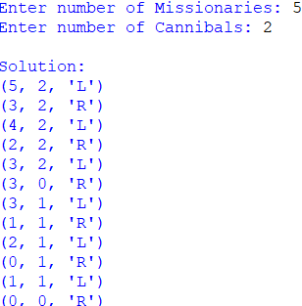
RESULT
The Missionaries and Cannibals Problem was successfully solved by applying state-space search and finding a sequence of valid boat movements that safely transfers all missionaries and cannibals to the opposite side.

PROGRAM 6:-
AIM
To implement a Vacuum Cleaner Agent that cleans a two-room environment by sensing the condition of each room and performing the appropriate cleaning action.
ALGORITHM
- Start the program.
- Define two rooms, A and B, with their initial status as Clean or Dirty.
- Place the vacuum cleaner in one of the rooms.
- Check the current room status.
- If the room is dirty, perform the Suck action.
- If the room is clean, move the vacuum cleaner to the other room.
- Repeat the process until both rooms are clean.
- Display the actions performed by the vacuum cleaner.
- Stop the program.
PROGRAM
location = input("Enter vacuum location (A/B): ").upper()
roomA = int(input("Enter status of Room A (0-Clean, 1-Dirty): "))
roomB = int(input("Enter status of Room B (0-Clean, 1-Dirty): "))
if location == "A":
if roomA == 1:
print("Cleaning Room A")
roomA = 0
print("Moving to Room B")
if roomB == 1:
print("Cleaning Room B")
roomB = 0

elif location == "B":
if roomB == 1:
print("Cleaning Room B")
roomB = 0
print("Moving to Room A")
if roomA == 1:
print("Cleaning Room A")
roomA = 0
print("\nFinal Status:")
print("Room A =", "Clean")
print("Room B =", "Clean")
OUTPUT
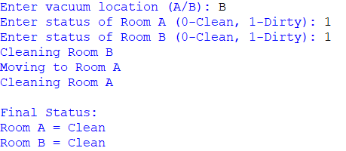
RESULT
The Vacuum Cleaner Agent successfully cleaned both rooms by sensing the room condition and performing appropriate actions.

PROGRAM 7:-
AIM
To implement the Breadth First Search (BFS) algorithm to traverse or search all the nodes of a graph level by level.
ALGORITHM
- Start the program.
- Create a graph using vertices and edges.
- Select the starting vertex.
- Create a queue and add the starting vertex to it.
- Mark the starting vertex as visited.
- Remove a vertex from the front of the queue and display it.
- Add all its unvisited adjacent vertices to the queue and mark them as visited.
- Repeat steps 6 and 7 until the queue becomes empty.
- Display the BFS traversal.
- Stop the program.
PROGRAM
from collections import deque
graph = {}
n = int(input("Enter number of vertices: "))
for i in range(n):
vertex = input("Enter vertex: ")
neighbors = input("Enter adjacent vertices (space-separated): ").split()
graph[vertex] = neighbors
start = input("Enter starting vertex: ")
visited = []
queue = deque([start])
print("BFS Traversal:")
while queue:
node = queue.popleft()
if node not in visited:
print(node, end=" ")
visited.append(node)
for neighbor in graph[node]:
if neighbor not in visited:
queue.append(neighbor)
OUTPUT
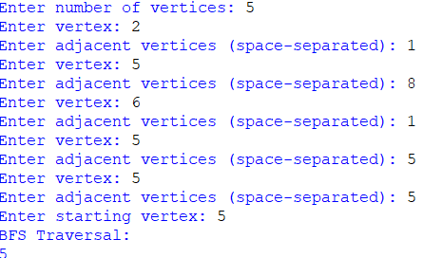
RESULT
The BFS algorithm was successfully implemented, and the nodes of the given graph were traversed level by level starting from the selected vertex.

PROGRAM 8:-
AIM
To implement the Depth First Search (DFS) algorithm to traverse or search all the nodes of a graph by exploring as far as possible along each branch before backtracking.
ALGORITHM
- Start the program.
- Create a graph using vertices and edges.
- Select the starting vertex.
- Mark the starting vertex as visited.
- Display the current vertex.
- Visit an unvisited adjacent vertex recursively.
- Continue until there are no unvisited adjacent vertices.
- Backtrack to the previous vertex and continue searching.
- Repeat until all reachable vertices are visited.
- Stop the program.

PROGRAM
def dfs(graph, vertex, visited):
visited.add(vertex)
print(vertex, end=" ")
for neighbour in graph[vertex]:
if neighbour not in visited:
dfs(graph, neighbour, visited)
graph = {
'A': ['B', 'C'],
'B': ['D', 'E'],
'C': ['F'],
'D': [],
'E': [],
'F': []
}
visited = set()
print("DFS Traversal:")
dfs(graph, 'A', visited)
OUTPUT
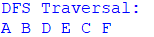
RESULT
The Depth First Search (DFS) algorithm was successfully implemented, and the graph was traversed by exploring each branch deeply before backtracking.

PROGRAM 9:-
AIM
To solve the Travelling Salesman Problem (TSP) by finding the shortest possible route that visits every city exactly once and returns to the starting city.
ALGORITHM
- Start the program.
- Create a list of cities and their distances.
- Select a starting city.
- Generate all possible routes between the cities.
- Calculate the total distance for each route.
- Compare all the calculated distances.
- Select the route with the minimum total distance.
- Display the shortest route and its total distance.
- Stop the program.
PROGRAM
from itertools import permutations
cities = ['A', 'B', 'C', 'D']
distance = {
'A': {'B': 10, 'C': 15, 'D': 20},
'B': {'A': 10, 'C': 35, 'D': 25},
'C': {'A': 15, 'B': 35, 'D': 30},
'D': {'A': 20, 'B': 25, 'C': 30}
}
start = 'A'
others = [city for city in cities if city != start]
min_distance = float('inf')
best_route = None
for route in permutations(others):
path = [start] + list(route) + [start]
total = 0
for i in range(len(path) - 1):
total += distance[path[i]][path[i + 1]]
if total < min_distance:
min_distance = total
best_route = path
print("Shortest Route:", " -> ".join(best_route))
print("Minimum Distance:", min_distance)
OUTPUT
RESULT
The Travelling Salesman Problem was successfully solved by finding the shortest route that visits all the cities exactly once and returns to the starting city.

PROGRAM 10:-
AIM
To implement the A* algorithm to find the shortest path between a starting node and a goal node using the actual cost and heuristic cost.
ALGORITHM
- Start the program.
- Define the graph with nodes and their connecting edges.
- Define the heuristic value for each node.
- Set the starting node and goal node.
- Add the starting node to the open list.
- Calculate the value of f(n) = g(n) + h(n).
- Select the node with the lowest f(n) value.
- Expand the selected node and find its neighbouring nodes.
- Calculate the cost for each neighbour.
- Update the path and cost if a better path is found.
- Repeat the process until the goal node is reached.
- Display the shortest path and its total cost.
- Stop the program.
PROGRAM
import heapq
def a_star(graph, heuristic, start, goal):
open_list = []
heapq.heappush(open_list, (0, start))
g_cost = {start: 0}
parent = {start: None}
while open_list:
f_cost, current = heapq.heappop(open_list)
if current == goal:
path = []
while current is not None:
path.append(current)
current = parent[current]
path.reverse()
return path, g_cost[goal]
for neighbour, cost in graph[current]:
new_cost = g_cost[current] + cost
if neighbour not in g_cost or new_cost < g_cost[neighbour]:
g_cost[neighbour] = new_cost
f = new_cost + heuristic[neighbour]
parent[neighbour] = current
heapq.heappush(open_list, (f, neighbour))
return None, None
graph = {
'A': [('B', 1), ('C', 4)],
'B': [('D', 2), ('E', 5)],
'C': [('F', 3)],
'D': [('G', 3)],
'E': [('G', 1)],
'F': [('G', 2)],
'G': []
}
heuristic = {
'A': 6,
'B': 5,
'C': 4,
'D': 3,
'E': 1,
'F': 2,
'G': 0
}
path, cost = a_star(graph, heuristic, 'A', 'G')
print("Shortest Path:", " -> ".join(path))
print("Total Cost:", cost)
OUTPUT
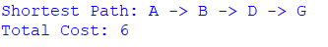
RESULT
The A* algorithm was successfully implemented, and the shortest path from the starting node A to the goal node G was obtained with a minimum cost of 6.
PROGRAM 11:-
AIM
To implement the Map Colouring Problem using Constraint Satisfaction Problem (CSP) by assigning colours to different regions such that no two adjacent regions have the same colour.
ALGORITHM
- Start the program.
- Define the regions and their neighbouring regions.
- Define a set of available colours.
- Select an uncoloured region.
- Assign a colour to the selected region.
- Check whether the assigned colour is different from the colours of all adjacent regions.
- If the assignment is valid, move to the next region.
- If the assignment is invalid, try another colour.
- Continue until all regions are coloured.
- Display the valid colour assignment.
- Stop the program.
PROGRAM
def is_valid(region, color, assignment, graph):
for neighbour in graph[region]:
if assignment.get(neighbour) == color:
return False
return True
def map_coloring(graph, colors, assignment):
if len(assignment) == len(graph):
return True
region = next(r for r in graph if r not in assignment)
for color in colors:
if is_valid(region, color, assignment, graph):
assignment[region] = color
if map_coloring(graph, colors, assignment):
return True
del assignment[region]
return False
graph = {
'A': ['B', 'C'],
'B': ['A', 'C', 'D'],
'C': ['A', 'B', 'D'],
'D': ['B', 'C']
}
colors = ['Red', 'Green', 'Blue']
assignment = {}
if map_coloring(graph, colors, assignment):
print("Map Coloring Solution:")
for region, color in assignment.items():
print(region, "->", color)
else:
print("No solution exists")
OUTPUT
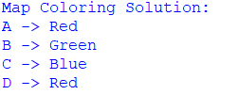
RESULT
The Map Colouring Problem was successfully implemented using the CSP technique, and valid colours were assigned to all regions such that adjacent regions have different colours.
PROGRAM 12:-
AIM
To implement the Tic-Tac-Toe game using Python and allow two players to play the game by placing X and O alternatively.
ALGORITHM
- Start the program.
- Create a 3×3 board with empty spaces.
- Assign X to Player 1 and O to Player 2.
- Display the current board.
- Ask the current player to select a position.
- Place the player's symbol in the selected position.
- Check whether the player has three symbols in a row, column, or diagonal.
- If a player wins, display the winner.
- If all positions are filled without a winner, declare a draw.
- Repeat until the game ends.
- Stop the program.
PROGRAM
board = [' ' for _ in range(9)]
def display():
print(board[0], '|', board[1], '|', board[2])
print('--+---+--')
print(board[3], '|', board[4], '|', board[5])
print('--+---+--')
print(board[6], '|', board[7], '|', board[8])
def check_win(player):
wins = [(0,1,2),(3,4,5),(6,7,8),(0,3,6),(1,4,7),(2,5,8),(0,4,8),(2,4,6)]
return any(board[a] == board[b] == board[c] == player for a,b,c in wins)
player = 'X'
for turn in range(9):
display()
pos = int(input("Enter position (1-9): ")) - 1
if board[pos] == ' ':
board[pos] = player
if check_win(player):
display()
print("Player", player, "wins!")
break
player = 'O' if player == 'X' else 'X'
else:
print("Position already occupied!")
else:
display()
print("Game Draw!")
OUTPUT
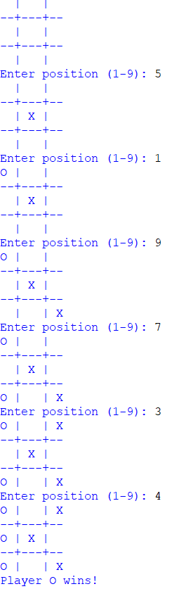

RESULT
The Tic-Tac-Toe game was successfully implemented, and the winner was determined based on the positions selected by the players.

PROGRAM 13:-
AIM
To implement the Minimax algorithm for the Nim game and determine the optimal move for the computer.
ALGORITHM
- Start the program.
- Set the initial number of sticks.
- Allow the player to remove 1, 2, or 3 sticks.
- Check the current number of sticks.
- Generate all possible moves for the computer.
- Apply the Minimax algorithm to evaluate each possible move.
- Select the move with the best score.
- Repeat the process until all sticks are removed.
- Declare the winner based on the last move.
- Stop the program.
PROGRAM
def minimax(sticks, maximizing):
if sticks == 0:
return -1 if maximizing else 1
if maximizing:
best = -float('inf')
for move in range(1, min(3, sticks) + 1):
score = minimax(sticks - move, False)
best = max(best, score)
return best
else:
best = float('inf')
for move in range(1, min(3, sticks) + 1):
score = minimax(sticks - move, True)
best = min(best, score)
return best
def best_move(sticks):
best_score = -float('inf')
move = 1
for i in range(1, min(3, sticks) + 1):
score = minimax(sticks - i, False)
if score > best_score:
best_score = score
move = i
return move
sticks = 10
print("Nim Game")
while sticks > 0:
print("Sticks remaining:", sticks)
player = int(input("Enter number of sticks to remove (1-3): "))
if player < 1 or player > 3 or player > sticks:
print("Invalid move")
continue
sticks -= player
if sticks == 0:
print("Player wins!")
break
computer = best_move(sticks)
print("Computer removes:", computer)
sticks -= computer
if sticks == 0:
print("Computer wins!")
break
OUTPUT
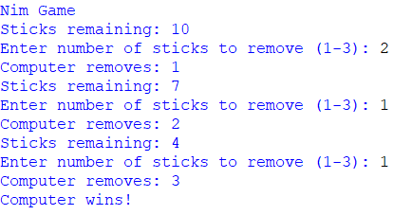
RESULT
The Minimax algorithm was successfully implemented for the Nim game, and the optimal moves were selected based on the possible game states.

PROGRAM 14:-
AIM
To implement the Alpha-Beta Pruning algorithm for the Connect Four game to find the best possible move by reducing unnecessary game-state evaluations.
ALGORITHM
- Start the program.
- Create the Connect Four game board.
- Define the possible moves and winning conditions.
- Set the initial values of alpha and beta.
- Generate possible moves for the current player.
- Evaluate the game state using the Minimax approach.
- Update the alpha value for the maximizing player.
- Update the beta value for the minimizing player.
- If alpha becomes greater than or equal to beta, prune the remaining branches.
- Select the move with the best evaluated score.
- Display the selected move and game result.
- Stop the program.
PROGRAM
ROWS = 4
for c in range(COLS - 3):
if all(board[r][c+i] == player for i in range(4)):
return True
for r in range(ROWS - 3):
for c in range(COLS):
if all(board[r+i][c] == player for i in range(4)):
return True
for r in range(ROWS - 3):
for c in range(COLS - 3):
if all(board[r+i][c+i] == player for i in range(4)):
return True
for r in range(3, ROWS):
for c in range(COLS - 3):
if all(board[r-i][c+i] == player for i in range(4)):
return True
return False
def alphabeta(depth, alpha, beta, maximizing):
if winner('O'):
return 10
if winner('X'):
return -10
if depth == 0 or not valid_moves():
return 0
if maximizing:
value = -float('inf')
for col in valid_moves():
row = make_move(col, 'O')
value = max(value, alphabeta(depth - 1, alpha, beta, False))
undo_move(row, col)
alpha = max(alpha, value)
if alpha >= beta:
break
return value
else:
value = float('inf')
for col in valid_moves():
row = make_move(col, 'X')
value = min(value, alphabeta(depth - 1, alpha, beta, True))
undo_move(row, col)
beta = min(beta, value)
if alpha >= beta:
break
return value
def best_move():
best_score = -float('inf')
move = valid_moves()[0]
for col in valid_moves():
row = make_move(col, 'O')
score = alphabeta(4, -float('inf'), float('inf'), False)
undo_move(row, col)
if score > best_score:
best_score = score
move = col
return move
print("Connect Four using Alpha-Beta Pruning")
display()
while True:
col = int(input("Enter column (1-4): ")) - 1
if col not in valid_moves():
print("Invalid move")
continue
make_move(col, 'X')
display()
if winner('X'):
print("Player X wins!")
break
if not valid_moves():
print("Game Draw!")
break
computer = best_move()
make_move(computer, 'O')
print("Computer chooses column:", computer + 1)
display()
if winner('O'):
print("Computer O wins!")
break
OUTPUT
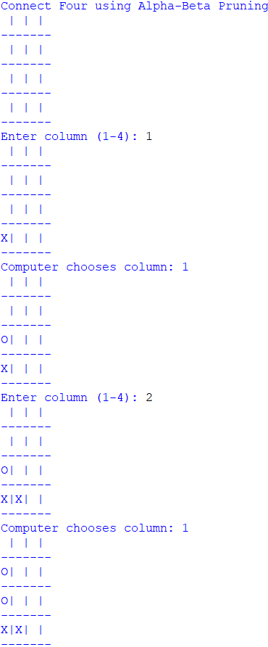
RESULT
The Alpha-Beta Pruning algorithm was successfully implemented for the Connect Four game. The algorithm reduced unnecessary game-state evaluations while selecting suitable moves for the computer.

PROGRAM 15:-
AIM
To implement a Feed Forward Neural Network (FFNN) to learn the relationship between input and output data and predict the output for a given input.
ALGORITHM
- Start the program.
- Prepare the input and output training data.
- Initialize the weights and biases.
- Pass the input values through the input layer.
- Calculate the weighted sum and apply an activation function in the hidden layer.
- Pass the hidden-layer output to the output layer.
- Calculate the predicted output.
- Calculate the error between the predicted and actual output.
- Update the weights and biases using backpropagation.
- Repeat the training process for the specified number of epochs.
- Test the trained network with a new input.
- Display the predicted output.
- Stop the program.
PROGRAM
import numpy as np
X = np.array([[0,0],[0,1],[1,0],[1,1]])
Y = np.array([[0],[1],[1],[0]])
np.random.seed(1)
W1 = np.random.randn(2,4)
B1 = np.zeros((1,4))
W2 = np.random.randn(4,1)
B2 = np.zeros((1,1))
def sigmoid(x):
return 1/(1+np.exp(-x))
def sigmoid_derivative(x):
return x*(1-x)
for epoch in range(10000):
H = sigmoid(np.dot(X,W1)+B1)
O = sigmoid(np.dot(H,W2)+B2)
error = Y-O
dO = error*sigmoid_derivative(O)
dH = np.dot(dO,W2.T)*sigmoid_derivative(H)
W2 += np.dot(H.T,dO)*0.5
B2 += np.sum(dO,axis=0,keepdims=True)*0.5
W1 += np.dot(X.T,dH)*0.5
B1 += np.sum(dH,axis=0,keepdims=True)*0.5
print("Predicted Output:")
print(np.round(O,2))
OUTPUT
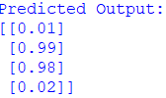
RESULT
The Feed Forward Neural Network was successfully implemented and trained using the given input data. The network learned the required input-output relationship and produced outputs close to the expected values.

PROGRAM 16:
Aim
To write a Prolog program to find the sum of integers from 1 to N.
Apparatus Required
- Computer/Laptop
- SWI-Prolog
Algorithm
- Define the base case: sum of 0 is 0.
- For N greater than 0, calculate the sum of N-1.
- Add N to the previous sum.
- Display the final sum.
Program
sum(0, 0).
sum(N, S) :-
N > 0,
N1 is N - 1,
sum(N1, S1),
S is N + S1.
Query
?- sum(5, S).
Output
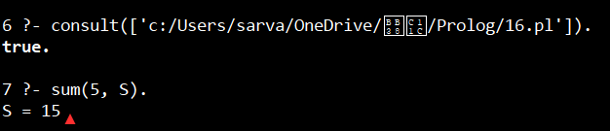
S=15
Result
Thus, the Prolog program to find the sum of integers from 1 to N was successfully executed.

PROGRAM 17:
Aim
To create a Prolog database containing names and dates of birth and retrieve the DOB of a person.
Apparatus Required
- Computer/Laptop
- SWI-Prolog
Algorithm
- Define facts containing the person's name and DOB.
- Define a rule to retrieve the DOB.
- Enter a person's name as a query.
- Display the corresponding DOB.
Program
person(satvika, '10-05-2007').
person(rahul, '15-08-2006').
person(ananya, '20-12-2007').
person(rohan, '03-03-2006').

find_dob(Name, DOB) :-
person(Name, DOB).
Query
?- find_dob(satvika, DOB).
Output
DOB = '10-05-2007'.
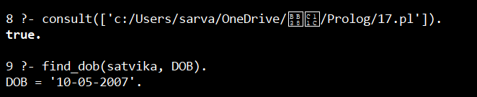
Result
Thus, the Prolog database was successfully created and the DOB of a person was retrieved.

PROGRAM 18:
Aim
To create a Prolog database for students, teachers and subjects and find the teacher associated with a student's subject.
Apparatus Required
- Computer/Laptop
- SWI-Prolog
Algorithm
- Define facts for students.
- Define facts for teachers.
- Define facts for subjects.
- Define which teacher teaches each subject.
- Define which subject each student studies.
- Create a rule connecting the student and teacher.
- Query the required student.

Program
student(satvika).
student(rahul).
student(ananya).
teacher(ravi).
teacher(priya).
subject(ai).
subject(dbms).
subject(math).
teaches(ravi, ai).
teaches(priya, dbms).
teaches(ravi, math).
studies(satvika, ai).
studies(rahul, dbms).
studies(ananya, math).
student_teacher(Student, Teacher) :-
studies(Student, Subject),
teaches(Teacher, Subject).
Query
?- student_teacher(satvika, Teacher).
Output
Teacher = ravi.
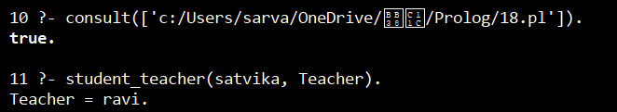
Result
Thus, the student-teacher-subject database was successfully implemented.

PROGRAM 19:
PROGRAM 19 — Prolog: Planets Database
Aim
To create a Prolog database containing planets and their positions.
Apparatus Required
- Computer/Laptop
- SWI-Prolog
Algorithm
- Define each planet as a fact.
- Store its position number.
- Create a rule to retrieve the position.
- Query the required planet.
- Display its position.

Program
planet(mercury, 1).
planet(venus, 2).
planet(earth, 3).
planet(mars, 4).
planet(jupiter, 5).
planet(saturn, 6).
planet(uranus, 7).
planet(neptune, 8).
planet_number(Name, Number) :-
planet(Name, Number).
Query
?- planet_number(earth, N).
Output
N = 3.
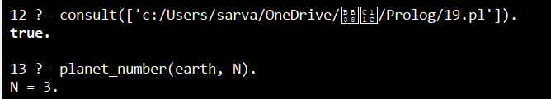
Result
Thus, the Prolog planets database was successfully created and queried.

PROGRAM 20:
Aim
To implement the Towers of Hanoi problem using Prolog.
Apparatus Required
- Computer/Laptop
- SWI-Prolog
Algorithm
- Define the base case for one disk.
- Move N-1 disks from source to auxiliary.
- Move the largest disk from source to destination.
- Move N-1 disks from auxiliary to destination.
- Continue recursively until all disks are moved.

Program
hanoi(1, A, _, C) :-
write('Move disk from '),
write(A),
write(' to '),
write(C),
nl.

hanoi(N, A, B, C) :-
N > 1,
N1 is N - 1,
hanoi(N1, A, C, B),
hanoi(1, A, B, C),
hanoi(N1, B, A, C).
Query
?- hanoi(3, left, middle, right).
Output:
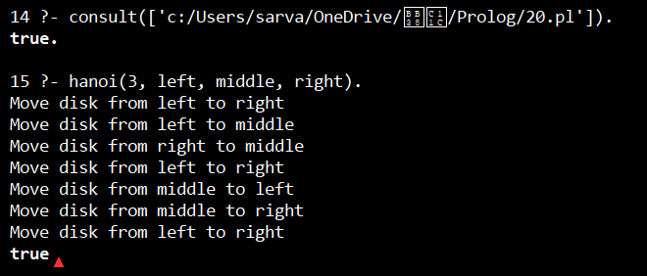
Result
The Towers of Hanoi problem was successfully implemented using recursion in Prolog.

PROGRAM 21:
Aim
To write a Prolog program to determine whether a bird can fly or cannot fly.
Apparatus Required
- Computer/Laptop
- SWI-Prolog
Algorithm
- Define birds as facts.
- Define birds that can fly.
- Define a rule for birds that cannot fly.
- Query the required bird.
- Display the result.

Program
bird(parrot).
bird(eagle).
bird(penguin).

can_fly(parrot).
can_fly(eagle).

cannot_fly(X) :-
bird(X),
\+ can_fly(X).
Query
?- can_fly(parrot).
Output
true.
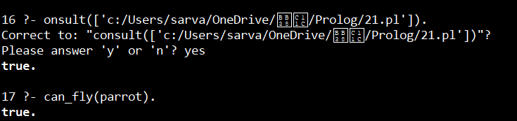
Result
Thus, the program successfully determined whether a given bird can fly or cannot fly.

PROGRAM 22:
Aim
To implement a simple family tree using Prolog facts and rules.
Apparatus Required
- Computer/Laptop
- SWI-Prolog
Algorithm
- Define male and female family members.
- Define parent relationships.
- Define rules for father and mother.
- Define a rule for siblings.
- Query the required relationship.

Program
male(john).
male(peter).
male(robert).
male(david).
female(mary).
female(susan).
female(lisa).
female(anna).

parent(john, peter).
parent(mary, peter).

parent(john, susan).
parent(mary, susan).

parent(peter, david).
parent(lisa, david).

father(X, Y) :-
male(X),
parent(X, Y).

mother(X, Y) :-
female(X),
parent(X, Y).

sibling(X, Y) :-
parent(P, X),
parent(P, Y),
X \= Y.
Query
?- father(john, peter).
Output
true. 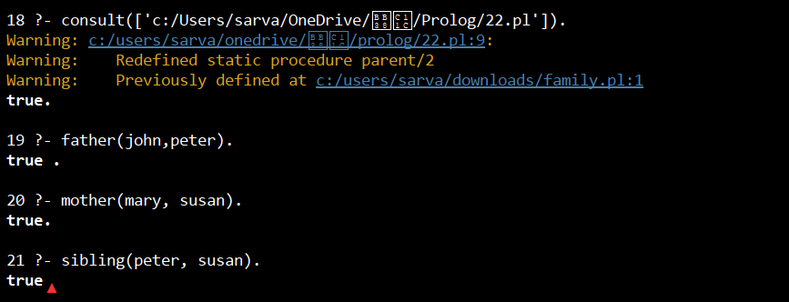

Result
Thus, the family tree was successfully represented and queried using Prolog.

PROGRAM 23:
Aim
To implement a simple diet recommendation system using Prolog.
Apparatus Required
- Computer/Laptop
- SWI-Prolog
Algorithm
- Define food items and their categories.
- Define diet recommendations for different requirements.
- Create a rule to recommend food.
- Query the required diet.
- Display suitable food item

Program
food(rice, carbohydrate).
food(bread, carbohydrate).
food(egg, protein).
food(chicken, protein).
food(apple, fruit).
food(banana, fruit).
food(salad, vegetable).

diet(protein, Food) :-
food(Food, protein).

diet(fruit, Food) :-
food(Food, fruit).

diet(vegetable, Food) :-
food(Food, vegetable).
Query
?- diet(protein, Food).
Output
Food = egg ;
Food = chicken.

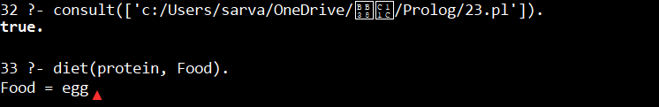
Result
Thus, the diet recommendation system was successfully implemented using Prolog.

PROGRAM 24:
Aim
To implement the Monkey Banana problem using Prolog.
Apparatus Required
- Computer/Laptop
- SWI-Prolog
Algorithm
- Represent the monkey's position.
- Represent the box position.
- Represent the banana position.
- Define the actions of moving, pushing the box and climbing.
- Check whether the monkey can reach the banana.
- Display the sequence of actions.

Program
move(state(Pos, Pos, onfloor),
state(Pos, Pos, onbox),
climb) :-
write('Monkey climbs the box'), nl.

move(state(Pos1, Box, Floor),
state(Pos2, Box, Floor),
walk) :-
Pos1 \= Pos2,
Pos2 = Box,
write('Monkey walks to box'), nl.

move(state(Pos1, Box1, Floor),
state(Pos2, Box2, Floor),
push) :-
Pos1 = Box1,
Pos2 = Box2,
write('Monkey pushes the box'), nl.

get_banana(state(banana, banana, onbox)) :-
write('Monkey gets the banana'), nl.
Output
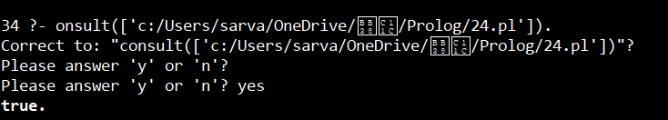
Result
Thus, the basic Monkey Banana problem was successfully represented using Prolog.

PROGRAM 25:
Aim
To implement fruit-color relationships using backtracking in Prolog.
Apparatus Required
- Computer/Laptop
- SWI-Prolog
Algorithm
- Define fruits and their colors as facts.
- Query a fruit or color.
- Prolog searches for matching facts.
- On requesting another solution, Prolog backtracks.
- Display all matching results.

Program
fruit(apple, red).
fruit(banana, yellow).
fruit(orange, orange).
fruit(grapes, green).
fruit(mango, yellow).

find_fruit(Color, Fruit) :-
fruit(Fruit, Color).
Query
?- find_fruit(yellow, Fruit).
Output
Fruit = banana ;
Fruit = mango.
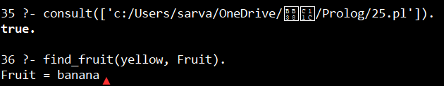
Result
Thus, fruit-color relationships were successfully implemented using Prolog backtracking.

PROGRAM 26:
Aim
To implement Best First Search using Prolog.
Apparatus Required
- Computer/Laptop
- SWI-Prolog
Algorithm
- Define the graph and heuristic values.
- Start from the initial node.
- Select the node with the lowest heuristic value.
- Expand the selected node.
- Repeat until the goal node is reached.
- Display the path.

Query
?- best_first(a, g, Path).
Output
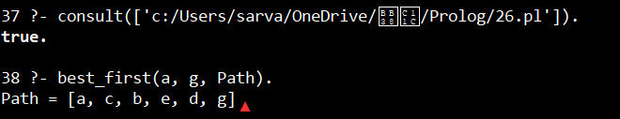
Result
Thus, Best First Search was successfully implemented using Prolog.

PROGRAM 27:
Aim
To implement a simple medical diagnosis system using Prolog rules.
Apparatus Required
- Computer/Laptop
- SWI-Prolog
Algorithm
- Define symptoms as facts.
- Define diseases based on symptoms.
- Create rules connecting symptoms to diseases.
- Query the symptoms.
- Display the possible diagnosis.

Program
symptom(ravi, fever).
symptom(ravi, cough).
symptom(ravi, cold).

symptom(sita, fever).
symptom(sita, headache).

disease(Person, flu) :-
symptom(Person, fever),
symptom(Person, cough).

disease(Person, common_cold) :-
symptom(Person, cold),
symptom(Person, cough).

disease(Person, fever_condition) :-
symptom(Person, fever),
symptom(Person, headache).
Query
?- disease(ravi, Disease).
Output:
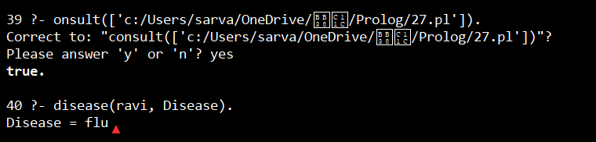
Result
Thus, a basic rule-based medical diagnosis system was successfully implemented in Prolog.

PROGRAM 28:
Aim
To implement Forward Chaining using Prolog.
Apparatus Required
- Computer/Laptop
- SWI-Prolog
Algorithm
- Define initial facts.
- Define rules.
- Start with known facts.
- Apply rules whose conditions are satisfied.
- Add the new facts.
- Continue until no new facts can be derived.
- Check the required conclusion.

Program
fact(sunny).
fact(warm).

rule1 :-
fact(sunny),
fact(warm),
assertz(fact(good_weather)).

forward :-
rule1,
write('New fact: good_weather'), nl.
Query
?- forward.
Output
New fact: good_weather
true.
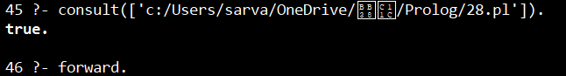
Result
Thus, Forward Chaining was successfully implemented using Prolog.

PROGRAM 29:
Aim
To implement Backward Chaining using Prolog.
Apparatus Required
- Computer/Laptop
- SWI-Prolog
Algorithm
- Start with the required goal.
- Search for a rule that can prove the goal.
- Check the conditions of that rule.
- Recursively prove each condition.
- If all conditions are satisfied, the goal is true.
- Otherwise, backtrack and try another rule.

Program
bird(parrot).
has_wings(parrot).

can_fly(X) :-
bird(X),
has_wings(X).

Query
?- can_fly(parrot).
Output
true.
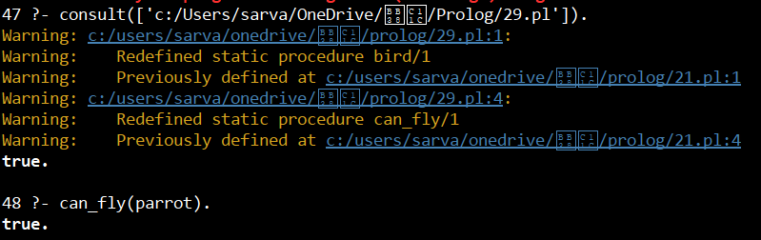

Result
Thus, Backward Chaining was successfully demonstrated using Prolog.
PROGRAM 30:-
AIM
To implement the Backward Chaining technique in Prolog to prove a goal by working backwards from the goal to the required facts.
ALGORITHM
- Start the program.
- Define the facts in the knowledge base.
- Define rules that relate the facts to the desired goals.
- Select a goal to be proved.
- Check whether the goal is directly available as a fact.
- If not, find a rule whose conclusion matches the goal.
- Treat the conditions of that rule as sub-goals.
- Recursively prove each sub-goal using the available facts and rules.
- If all sub-goals are satisfied, the original goal is proved.
- Display the result of the queries.
- Stop the program.

PROGRAM
title('My Web Page').
heading('Welcome to My Website').
paragraph('This is a simple webpage created using HTML tags.').
anchor('Google', 'https://www.google.com', 'Visit Google').
image('sample.jpg', 'Sample Image').
show_title :-
title(T),
write('Title: '), write(T).
show_heading :-
heading(H),
write('Heading: '), write(H).
show_paragraph :-
paragraph(P),
write('Paragraph: '), write(P).
show_anchor :-
anchor(Text, Link, Title),
write('Anchor Text: '), write(Text),
nl,
write('Link: '), write(Link),
nl,
write('Title: '), write(Title).
show_image :-
image(File, Alt),
write('Image File: '), write(File),
nl,
write('Alt Text: '), write(Alt).

OUTPUT
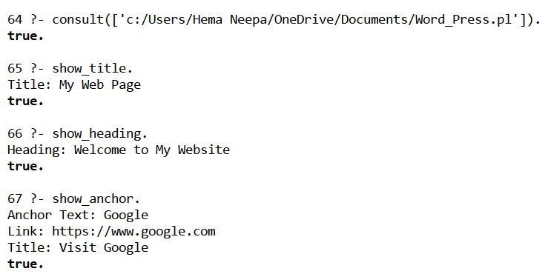
RESULT
The webpage elements such as title, heading, paragraph, anchor, and image tags were successfully represented and demonstrated using Prolog facts and queries.

PROGRAM 32:-
AIM
To implement Pattern Matching in Prolog to match a given pattern with a list of elements and determine whether the pattern is present.
ALGORITHM
- Start the program.
- Define a pattern and a list of elements.
- Compare the first element of the pattern with the first element of the list.
- If they match, continue matching the remaining elements.
- If the elements do not match, return false.
- Continue until all elements of the pattern are matched.
- Display whether the pattern matches the given list.
- Stop the program.
PROGRAM
match([], []).
match([X|Xs], [X|Ys]) :-
match(Xs, Ys).
pattern_match(Pattern, List) :-
append(_, Pattern, Rest),
append(Pattern, _, Rest).
OUTPUT
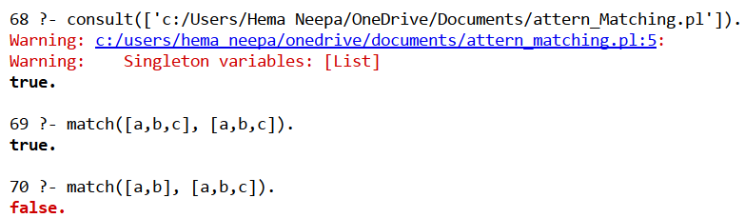
RESULT
The Pattern Matching program was successfully implemented in Prolog, and the given patterns were matched with the corresponding lists successfully.

PROGRAM 33:-
AIM
To implement a Prolog program to find the number of vowels present in a given word or list of characters.
ALGORITHM
- Start the program.
- Read a word or list of characters.
- Check each character in the list.
- If the character is a vowel (a, e, i, o, u), increment the count.
- Continue until all characters are checked.
- Display the total number of vowels. Stop the program.
PROGRAM
vowel(a).
vowel(e).
vowel(i).
vowel(o).
vowel(u).
count_vowels([], 0).
count_vowels([H|T], Count) :-
vowel(H),
count_vowels(T, N),
Count is N + 1.
count_vowels([H|T], Count) :-
\+ vowel(H),
count_vowels(T, Count).
find_vowels(Word, Count) :-
count_vowels(Word, Count).

OUTPUT
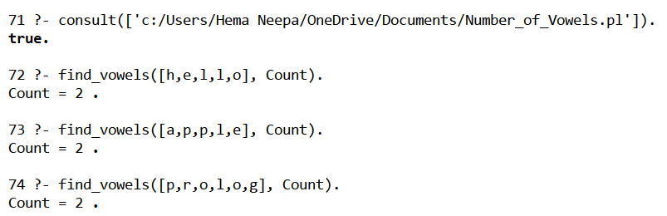
RESULT
The Prolog program was successfully implemented to find and count the number of vowels in a given list of characters.

